Additional Learning Needs - Parent/Carer Support Links:

- Vale Parenting Service - Parenting Programmes

https://www.valeofglamorgan.gov.uk/en/living/social_care/children_and_young_people/Family-Information-Service/family-zone/Parenting-Programmes.aspx

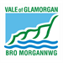

2) INDEX - Keeping families up to date with services, support and activities for children and young people with disabilities or additional needs across the Vale
https://www.valeofglamorgan.gov.uk/en/living/social_care/children_and_young_people/children_with_additional_needs/the-index/The-index.aspx

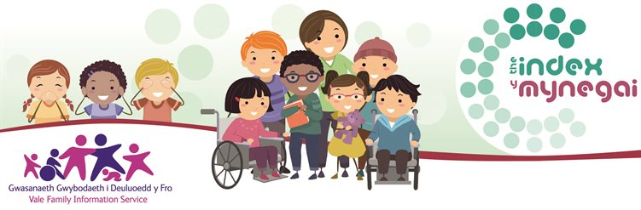

Vale of Glamorgan Adult Learning Services Free adult courses to 'get back on track' https://www.valeofglamorgan.gov.uk/en/working/adult_and_community_learning/Get-Back-on-Track/Get-Back-on-Track.aspx

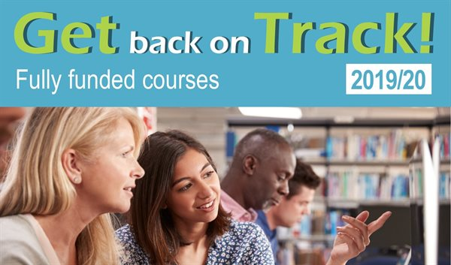
Families First- Advice Line, young careers, youth wellbeing, Vale parenting service.

https://www.valeofglamorgan.gov.uk/en/living/social_care/children_and_young_people/families_first/Families-First.aspx

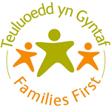

SNAP - provides info, advice and support for parents, children and young people who have or may have special educational needs or disabilities
http://www.snapcymru.org

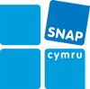

Youth Wellbeing Service - Welsh Government funded project based on a multi agency approach for supporting young people. https://www.valeofglamorgan.gov.uk/en/living/youth_service/Youth-Wellbeing-Service.aspx

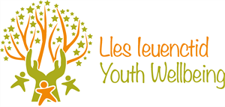

Vale Family Information Service- Information on childcare, activities and services for children and young people and family support in the the Vale of Glamorgan
https://www.valeofglamorgan.gov.uk/en/living/social_care/children_and_young_people/Family-Information-Service/Family-Information-Service.aspx

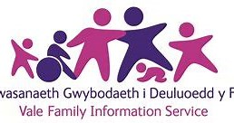

CAMHS - Child and Adolescent Mental Health Services

https://youngminds.org.uk/find-help/your-guide-to-support/guide-to-camhs/#what-is-camhs?

Cruse bereavement
https://www.cruse.org.uk/get-help/local-services/wales/cardiff-and-the-vale

Vale School based counselling service
https://www.valeofglamorgan.gov.uk/en/living/schools/School-Based-Counselling-Service.aspx

